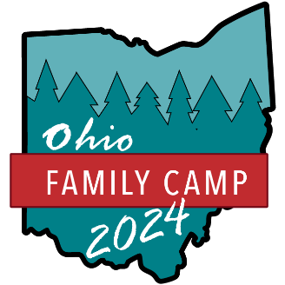
OHIO FAMILY CAMP PRICING SHEET
Registration
Full Week Event Registration  Age 12 and up - $54.00 per person paid by May 21, $64.00 per person paid by June 17, $74.00 per person onsite  Age 3-11 - $38.00 per person  Age 2 and under – free | Daily Event Registration  Age 12 and up - $12.00 per day  Age 3-11 - $8.00 per day  Age 2 and under – free  After 5pm: $5 for evening activities

Lodging
Camping  (RV full or partial hook up or tent camping)  $30.00 per night per site or $120.00 for Sunday-Friday morning  *1 RV and 1 tent OR 2 tent’s per site | Dormitory Style Rooms  $18.00 per person per night or $75.00 per person for Sunday-Friday morning  Age 2 and under - free  *1 family per room | Davidson Cabin  $875 for Sunday-Friday morning  *sleeps up to 6  Beechnut Lodge  $625 for Sunday-Friday morning or  $225 per night  *sleeps up to 4

Meals
Weekly Meal Package  Age 12 & up: $110.00 per person  Ages 3-11: $66.00 per person  Ages 2 & under: free  Includes Sunday night dinner through Friday breakfast. | Individual Meals  Breakfast  $8.00 (age 12 & up), $4.00 (age 3-11)  Lunch  $10.00 (age 12 & up), $6.00 (age 3-11)  Dinner  $12.00 (age 12 & up), $8.00 (age 3-11)

Fun Extra’s
Tie Dye T-Shirt Activity  $10.00 for child sizes, $12.00 for adult sizes | Golf Cart Rental  $300.00 for Sunday-Friday rental  (must be paid at time of registration)

There is a non-refundable $50 charge on each registration.

